

MA3910 PROFESSIONAL ATTACHMENT

Tan Yi Rong
U2320967K
School of Mechanical and Aerospace Engineering

Final Internship Report
Special Term / AY24-25

Acknowledgements
I would like to thank Mr. Ng Christopher, my internship supervisor, for his steady guidance and support throughout this internship. His mentorship provided a solid foundation for my technical learning and professional growth.
I am also sincerely grateful to Mr. Ian Carlos Salazar (Lead) and Mr. Mark Joseph Atienza, Senior Associate Engineers in the AMHS department, for working closely with me on the main project. Their willingness to share insights and guide me through technical discussions played a big part in my learning journey.
Special thanks to Mr. Tay See Hong for recommending certified vendors and manufacturer that aligned with our sensor and mount design needs.
I would also like to thank Mr. Tan Tiah Long for training me on AMHS operations and giving me a comprehensive tour of Fab 7, 7G, and 7H. His walkthroughs helped me connect the theory of OHT systems with their real-life application in the fab.
I appreciate Ms. Alvina for coordinating the intern onboarding process and arranging orientation briefings and training sessions that helped me settle into the company culture smoothly.
I am thankful as well to Mr. Nay Tun Naing and Mr. Alan Ho for offering guidance when I had questions or needed direction with technical tasks. Their help with navigating the internal folder system made it easier to manage documentation and locate the resources I needed.
Lastly, I would like to thank all the trainers involved in the orientation week sessions, including those who covered fire safety, IT policies, and workplace culture. These lessons gave me a clearer understanding of the company’s expectations and operational standards.

Table of Contents
Acknowledgements 2
1. Introduction 4
1.1 Company Overview 4
1.2 Internship Department: AMHS Fab 7 5
1.3 Internship Scope 5
2. AMHS Background 6
2.1 What is AMHS and the Role of OHT System 6
3. Main Project: Sensor System for OHT Wheel Monitoring 7
3.1 Current Manual Maintenance Process 7
3.2 Identified Issues 7
3.3 Objective of Project 7
3.4 Project Outline 8
3.5 Design and Academic Application 9
4. Supporting Tasks: 10
4.1 Orientation and Induction Training 10
4.2 High Power Inductance Device (HID) Data Management 11
5. Reflections 12
6. Appendices 13
6.1 Appendix A – Sensor Comparison Table 13
6.2 Appendix B – Sensor Mount Ideation and Designing 14
6.3 Appendix C – HID Label Improvement Example (Censored) 16
6.4 Appendix D - FOUP Movement Log Format (Censored) 17

1. Introduction

1.1 Company Overview
GlobalFoundries (GF) is a leading global semiconductor foundry that provides advanced manufacturing services for integrated circuits. Operating on a pure-play foundry model, GF manufactures chips designed by other companies. The company fosters a culture of innovation, collaboration and continuous improvement, with a strong emphasis on safety, quality and operational excellence.
GF offers a wide range of semiconductor manufacturing technologies, including radio frequency (RF), analog and embedded memory solutions. Its services span from design enablement to wafer fabrication and testing. GF serves global markets, with key customers in automotive, mobile, IoT and data centre sectors. Suppliers include equipment manufacturers and raw materials providers while competitors include TSMC, Samsung Foundry, UMC and Intel.
GF’s competitive edge lies in its focus on specialised process technologies and advanced packaging. At the heart of its Asia-Pacific operations, GF Singapore (APAC headquarters) operates Fab GIGA+ and Fab 7, 7G and 7H, which manufacture chips on both 200mm and 300mm wafers, supporting technologies from 350nm to 40nm.
GF APAC also fosters a supportive and inclusive work environment that emphasizes both professional development and employee well-being. The company offers a variety of employee engagement initiatives, including additional training, weekly sports activities, cultural celebrations, and team bonding events. GF Singapore has also been recognized as the Employee Experience Champion of the Year at the 2025 Employee Experience Awards in Singapore, winning multiple awards for its excellence in leadership, learning, engagement, and talent acquisition.
In addition, GF Singapore supports talent development through paid internships, traineeships, and work-study programs in collaboration with local institutions. These initiatives provide hands-on experience in semiconductor manufacturing and open pathways to full-time employment, reinforcing GF’s commitment to nurturing future talent in the region.

1.2 Internship Department: AMHS Fab 7
During my internship, I was attached to GF APAC under the Automated Material Handling System (AMHS) department at Fab7 as an automation equipment engineer. The department oversees the Overhead Hoist Transport (OHT) system, which automates the movement of Front Opening Unified Pods (FOUPs) which are known as wafer carriers between process tools in the cleanroom. This system plays a critical role in maintaining production efficiency and minimising contamination risks.

1.3 Internship Scope
The main objective of my project was to design a system that monitors the condition of OHT wheels in real time. By enabling predictive maintenance, the system helps reduce unplanned downtimes and supports more efficient spare part management. This contributes to improved OHT reliability and production across Fab 7, 7G and 7H
The main objective of my internship project was to develop a sensor-based monitoring system that measures the condition of OHT wheels in real time. This system will allow for automated data collection for AMHS maintenance and support for predictive replacement of wheel components. By identifying wear and tear early, the system helps to reduce error occurrences and improve Mean Moves Between Interrupts (MMBI) during production runs, ultimately enhancing overall fab’s productivity and reliability.
In addition to the main project, I also supported the team with ad-hoc tasks during downtimes or urgent prioritise tasks such as checking High Power Inductance Device (HID) data and capturing images of machine labels for documentation for overhaul planning.

2. AMHS Background

2.1 What is AMHS and the Role of OHT System
The Automated Material Handling System (AMHS) is a vital infrastructure within the semiconductor fab that ensures the smooth and efficient movement of materials. It is responsible for transferring FOUPs (Front Opening Unified Pods), which carry wafers, between different process tools in a highly controlled cleanroom environment. AMHS helps reduce manual handling, minimises contamination risk, and improves production flow.
One of the key components of the AMHS is the Overhead Hoist Transport (OHT) system. These are rail-guided vehicles that run on tracks suspended from the ceiling. OHTs pick up and deliver FOUPs based on instructions from the Material Control System (MCS). Because wafers are extremely sensitive to particles, vibrations, and delays, OHTs must operate with high accuracy and reliability. Any fault or downtime in the OHT system can disrupt the production schedule and reduce overall fab efficiency.
To support daily operations and ensure accountability, I attended the AMHS department's 8:00 AM daily passdown meetings. These meetings reviewed the previous day's Preventive Maintenance (PM) and Corrective Maintenance (CM) activities on the OHT systems. Line support engineers reported the specific issues encountered during their shifts, allowing for accountability when a repaired OHT returns with further issues. This detailed tracking ensures that the engineer who performed the previous maintenance can be identified and consulted, promoting responsibility and transparency in maintenance activities. These updates are used by senior engineers to document maintenance history in the AMHS data system and to identify any components that require urgent replacement or restocking.
The meeting also provided visibility on the total OHT utilization for Fab 7, 7G and 7H enabling trend analysis. Anomalies in utilization rates can affect overall production, as reduced OHT activity may indicate delays or inefficiencies in wafer transport. Additionally, AMHS oversees not only OHTs but also stockers, which function as storage systems for both empty and loaded FOUPs awaiting pickup. The performance of both systems contributes to the smooth operation of the fab.
The maintenance and performance of OHTs are critical to achieving high FOUPs move and meeting fab productivity goals. That is why improvements to OHT monitoring such as predictive maintenance systems, are important for reducing errors and unplanned downtimes in wafer transport operations.

3. Main Project: Sensor System for OHT Wheel Monitoring

3.1 Current Manual Maintenance Process
The main problem that my internship company has tasked me to address is the automation of the manual measurement process used to assess the wear and tear of the Overhead Hoist Transport (OHT) travel wheels. Currently, line support engineers manually measure the diameter of the OHT wheels using vernier caliper to determine whether the tire needs replacement or if a shim adjustment is necessary. However, this manual method has inconsistency in the results.

3.2 Identified Issues
As this process is prone to human error. Variations in pressure or measurement angle can lead to inconsistent and inaccurate readings. This is evident in the collected data, where some measurements appear to increase over time which contradicted the expected wear due to friction. These inconsistencies highlight the need for a more reliable and consistent method.
Additionally, wheel wear and tear can cause the OHT to lean slightly to one side, which may seem minor but can have significant effects down the line. For example, this misalignment can cause the FOUP look-down sensor to misdetect the FOUP’s position, as the sensor relies on precise distance and alignment. Even a small deviation can lead to failed pick-ups or transport delays, which in turn disrupt wafer flow and reduce fab efficiency. This reinforces the importance of early detection and predictive maintenance to prevent small mechanical issues from escalating into larger problems.

3.3 Objective of Project
To address this, the AMHS department aims to implement an automated system using sensors to effectively obtain accurate measurements. Additionally, the goal is to integrate machine learning techniques to predict remaining lifespan of the wheels and flag OHTs that require maintenance before major issues arise. This predictive maintenance approach would improve accuracy and reduce unplanned downtimes. My role involves analysing the manual maintenance process, identifying suitable sensor technologies, developing a prototype system and exploring predictive analytic models.

3.4 Project Outline
To address the issue of inconsistent manual measurements of OHT travel wheels, our project team led by two senior associate engineers, Ian and Mark, and supported by myself is developing an automated measurement system using sensors. The objective is to replace the current manual process with a more accurate and consistent method. In the long run, we aim to integrate machine learning techniques to predict tire wear and enable predictive maintenance. This solution is intended to reduce human error, improve data reliability and minimize unplanned downtimes.
The project is currently in its first phase, which involves ideation, sensor procurement and prototype design. I began by conducting on-site observations of the OHT system and maintenance workflow to better understand the operational and environmental constraints. These observations helped us define technical requirements such as measurement precision, sensor placement and future implementation feasibility.
I participated in planning discussions and conducted research on suitable sensor technologies including options from Keyence and Omron. We evaluated factors such as precision, compatibility, size and ease of integration. We also discussed the pros and cons of each sensor including ultrasonic, Light Detection and Ranging (LIDAR) and vision-based options. After evaluating the technical and cost aspects, we deemed LIDAR as the most cost-effective solution that still met our accuracy and integration needs. We created proposal slides for our supervisor,
Mr. Ng Christopher, explaining our selection criteria covering aspects such as placement of system, expected precision and the feasibility of implementation within the project timeline. These slides were necessary to justify our sensor recommendation and to ensure alignment on project direction before proceeding with prototyping.
A sample of the sensor comparison table is provided in Appendix A, Figure A.1 for reference.
The proposal is also intended to further convince decision-makers why this project is important for the company. In future proposal, we will be including the Return on Investment (ROI) to highlight the potential cost savings and operational efficiency the project brings in the long run. By presenting the long-term benefits and justifying the investment, the proposal aims to gain support and approval for full-scale implementation. These proposal materials are regularly updated throughout the project timeline to reflect design refinements, vendor feedback and implementation planning progress.
Once a suitable sensor is selected and tested, we will collect real-time data and compare it with historical records to validate accuracy. This data will later serve as the foundation for training a machine learning model to predict the remaining lifespan of the OHT wheels. The final solution will include a dashboard or alert system to notify engineers when an OHT is approaching its maintenance threshold.

3.5 Design and Academic Application
To support sensor mounting, I designed the mounting structure using CAD software, focusing on manufacturability and with accounts to the strict constraint of the location placement. This model also served as a reference when contacting manufacturers to request quotations for sensor mount fabrication.
To support this work:
- A sample of the measurement of the mount and placement is provided in Appendix B, Figure B.1.
- A sample of the ideation and designing of the sensor mount is provided in Appendix B, Figure B.2.
- A rough visualisation of sensor placement (LIDAR and future) is provided in Appendix B, Figure B.3.
- A conceptual design layout of the sensor mount structure, created in FreeCAD, is provided in Appendix B, Figure B.4.
The mechanical stability of the design will be validated using Free Body Diagram (FBD) calculations to ensure it can handle operational loads without failure. This step is intended to prevent any design flaws that could lead to remanufacturing or installation issues. The application of FBD analysis draws directly from my academic background in MA2001 Mechanics of Materials, while the ability to create detailed 3D models using CAD Software is a practical extension of what I learned in MA2005 Engineering Graphics through SolidWorks.
As this report covers progress up to Week 8, the CAD design and planning for FBD analysis represent the final steps in my current involvement. These tasks prepare the groundwork for the prototyping and testing phases that will continue during my Professional Internship (PI).
An additional challenge we identified is ensuring compatibility between the sensor system and the existing AMHS data infrastructure. Access to the OHT for installation and live testing will be crucial to validating the solution. Time constraints remain a key consideration as the remaining phases extend into the next internship cycle.

4. Supporting Tasks:

4.1 Orientation and Induction Training
As a mechanical engineering student with no prior background in the semiconductor industry, I found the initial orientation both overwhelming and eye-opening. This was also my first internship, so I entered the company with very limited understanding of semiconductor operations and terminology. During the first few weeks, I had to actively try to pick up industry-specific abbreviations and technical terms, which was a struggle at times. However, these orientation activities were essential to help me transition smoothly into the working environment.
During the initial weeks of the internship, I went through various orientation and training programmes. This included briefings on GF’s policies, fab safety, IT security, quality systems, and cleanroom operations. I also completed several e-learning modules such as diffusion, CMP, etching, photolithography, and thin film. These sessions helped build my understanding of wafer fabrication processes.
In addition, I observed maintenance practices on the ground, including how technicians inspect and adjust sensors like Anti-Collision Sensors (ACS) and look-down sensors, as well as how they apply lubricants to ensure the smooth movement of OHT systems. I also tried to assist in PM and CM activities on OHTs scheduled for servicing. Getting hands-on with these tasks gave me a much clearer understanding of how the OHT system operates mechanically and how each component contributes to its overall function.

4.2 High Power Inductance Device (HID)
Data Management
Aside from training, I was assigned supporting tasks when project work was temporarily on hold. One major assignment was relabelling all 243 HID machines across Fab7, 7g and Sub Fab. Previously, the HID plate and serial number were photographed separately, which made it untidy and difficult to match during data retrieval. This was especially confusing when trying to determine which HID plate belonged to which serial number. During an overhaul, the old HID's plate is reused on the new HID, so having both identifiers clearly visible in a single image helps streamline maintenance tracking and improve efficiency.
HID stands for High Power Inductance Device, which acts as a power interface unit supplying electricity to the OHT system as it moves along the track. Similar to how trains draw power through their rails, the HID powers the OHTs through inductive coupling when they pass by, enabling continuous and consistent movement throughout the fab.
I also compiled and verified HID data across several Excel sheets and reported inconsistencies to colleagues. Another task I undertook was tallying the FOUP movements of the OHTs assigned under each HID unit. This was to validate that each OHT's FOUP activity aligned with the data records tied to its specific HID tag. This task helped in cross-checking movement history and supported more accurate overhaul scheduling. It allowed us to prioritise HID units with low FOUP movement for earlier overhaul, since they impact production less and can be taken offline more readily. In contrast, HID units supporting high FOUP activity had to be scheduled for overhaul only during fab plant shutdowns, to avoid disrupting wafer flow and production throughput.
To support this work:
- A sample of the original HID label photo format is provided in Appendix C, Figure C.1.
- A sample of the Excel sheet used for tallying FOUP movements is provided in Appendix D, Figure D.1.
- A sample of the updated HID label photo format is provided in Appendix C, Figure C.2.
Although these tasks were tedious, they were important in streamlining HID data retrieval and ensuring data accuracy for future replacements and maintenance planning. This contributes to better maintenance planning and improves overall AMHS efficiency.

5. Reflections
This internship has been both demanding and rewarding. As a mechanical engineering student with no background in the semiconductor industry, stepping into GlobalFoundries was initially overwhelming. The cleanroom protocols, technical abbreviations and fab systems were all unfamiliar to me. However, the structured onboarding sessions, e-learning modules and on-the-ground training helped me adapt quickly. Over time, I grew more confident and became comfortable contributing to engineering discussions and tasks.
The highlight of my experience was supporting the development of an automated sensor system for monitoring OHT wheel wear. I participated in sensor evaluation, vendor coordination and proposal development. Applying what I had learned in MA2005 Engineering Graphics and MA2001 Mechanics of Materials, I designed a sensor mount in CAD software and prepared for FBD analysis to ensure structural reliability. I also helped draft proposal slides to justify sensor selection and align our approach with project goals. This process taught me how engineering knowledge translates into real-world design and project communication.
In addition to the main project, I handled side tasks such as validating HID data and relabeling over 240 HID units to improve traceability. I also tallied FOUP movement across OHTs to prioritise HID overhaul scheduling. These tasks, although tedious, gave me insight into how precise data handling supports fab operations. I learned that maintenance work, even at the data level has direct consequences on production uptime and scheduling.
Daily passdown meetings further helped me understand fab operations and the importance of accountability in maintenance activities. I saw how cross-shift communication, issue logging, and part ordering were managed efficiently. These sessions exposed me to the fast-paced, 24/7 nature of fab work and helped me appreciate the discipline and planning it requires.
As I progressed, I also began to understand the backend systems that keep the fab running such as the power supply infrastructure that energizes the OHT system and the MCS that determines the routing and destinations of each OHT. These systems operate silently in the background but are critical to the fab’s overall performance.
One key learning was how small mechanical issues, such as wheel wear and tear can cause the OHT to lean slightly to one side. This seemingly minor misalignment can significantly affect sensor detection accuracy especially since the FOUP pick-up sensor relies on precise distance and alignment. A deviation in sensor readings can lead to misdetection or failed pick-ups, which in turn disrupts wafer transport and causes delays. This experience helped me appreciate how small faults can snowball into larger disruptions across the production line, reinforcing the importance of proactive maintenance and system calibration.

6. Appendices
Note on Visuals: To comply with GlobalFoundries' confidentiality guidelines, visual materials such as CAD screenshots, internal data tables, or site-specific images have either been excluded or edited to remove any proprietary or sensitive content. Visual assets in this report are conceptual in nature and intended only to support general understanding of the project scope. Internal visuals are stored securely within the company’s internal systems and are available only to authorised personnel.

6.1 Appendix A – Sensor Comparison Table
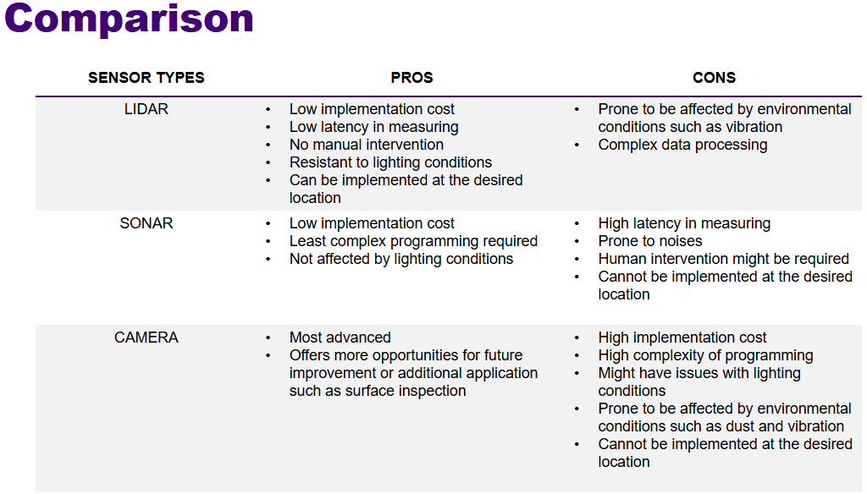
Figure A.1: Sensor Comparison Table

6.2 Appendix B – Sensor Mount Ideation and Designing
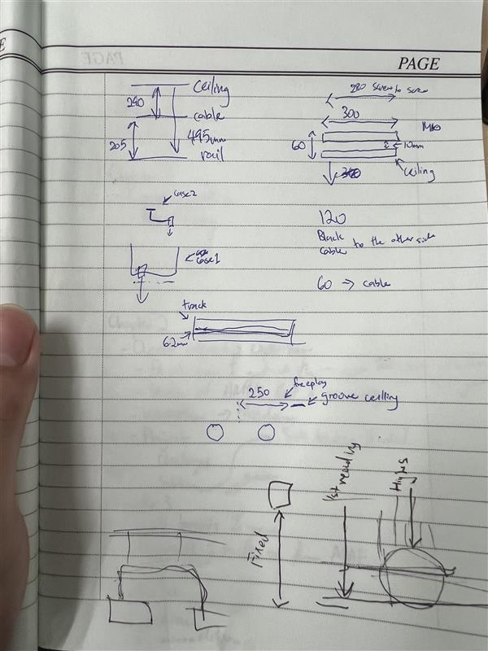
Figure B.1: Measurement of Mount and Placement
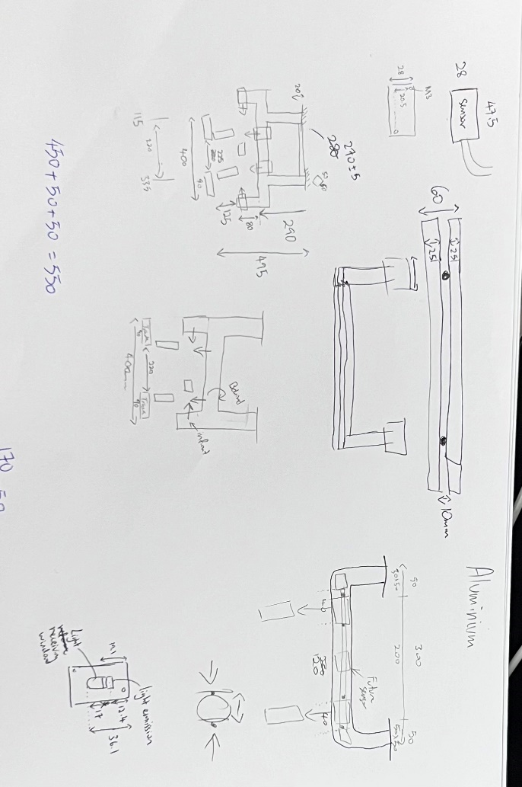
Figure B.2: Ideation and Designing of Sensor Mount
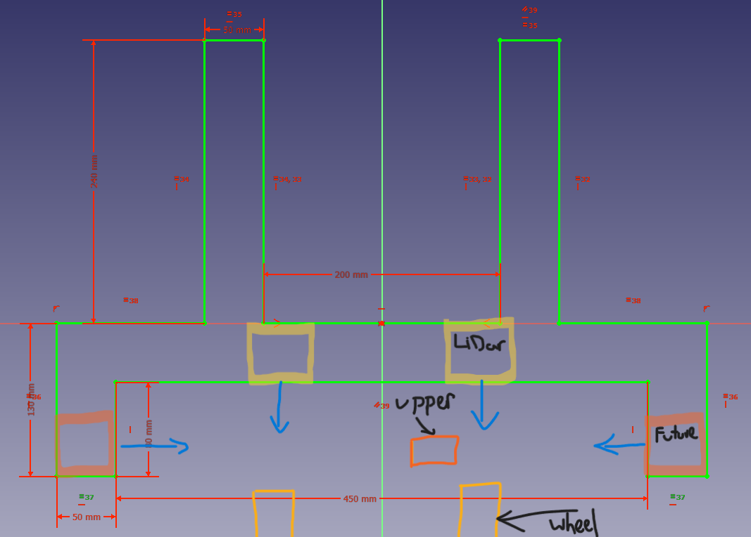
Figure B.3: Rough visualisation of sensor placement of LIDAR and future sensor
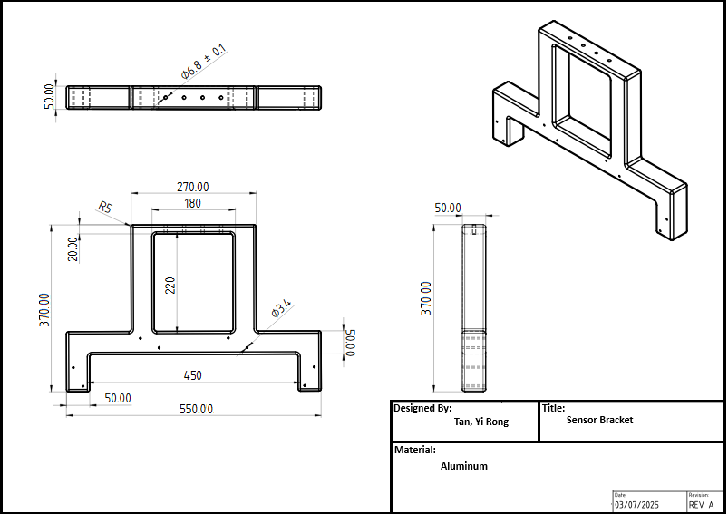
Figure B.4: Conceptual design layout of the sensor mount structure
created in FreeCAD

6.3 Appendix C – HID Label Improvement Example (Censored)
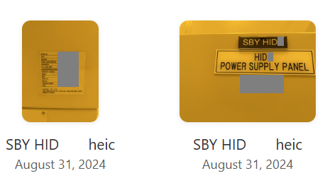
Figure C.1: Before: HID serial number and plate photo taken separately
leading to confusion during overhaul scheduling

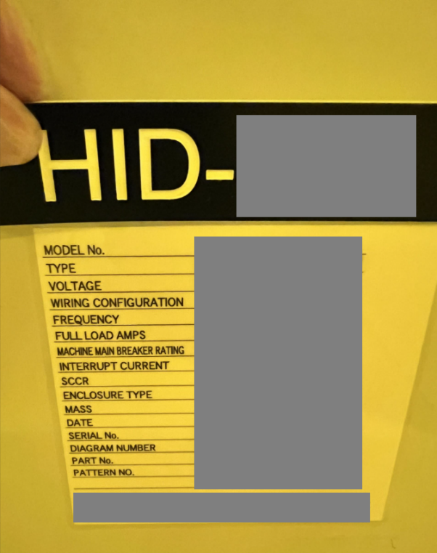
Figure C.2: After: Combined image of HID serial and plate for improved traceability

6.4 Appendix D - FOUP Movement Log Format (Censored)
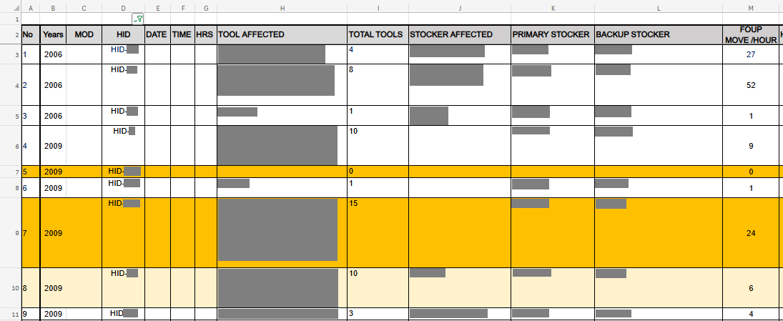
Figure D.1: Tallying of FOUP movements by OHT under each HID.
Used to prioritise least utilised HID for Overhaul

